Sprint 1 Planning

Overall

* Sprint ends Oct 23
* We will work on it for 24 hours
* Evaluate contribution using hours or task size
* Scrum Master: Austin G

Stories

1. (M) As a user, I want to open up my app and be welcomed with my home page with my active tournament
   * If I’m not logged in, I will be directed to a login page instead
2. (S) As a user, I want to be able to sign up as a Sponsor or Player
3. (L) As a Player, I want my home page to display:
   * a leaderboard of scores in my active tournament,
   * drink order queue/history w/ button to create/edit order
   * Current hole/ stroke count
4. (M) As a Sponsor, I want my home page to display:
   * my current tournament leaderboard,
   * tournament manager info
   * tournament prize info which I can edit
5. (S) As a user, I want to be able to sign in as a Barista or Manager with premade credentials
6. (M) As a Barista, I want my home page to display:
   * my current tournament I’m working for
   * an active drink queue for all orders coming from players in my tournament

Tasks

Story 1:

* Create login and index html page templates (S)
* Hook together and add urls for all html pages (S)
* Create models for Player, Sponsor, Barista, and Manager in database (S)
* Start building index page (M)
  + Only needs to display a simple message displaying user type for now
* Set up authentication/db management for login (S)

Story 2:

* Create specific login form at login page for different type of signup (S)
  + Sponsor just needs a name and password
  + Player needs email, username and password

Story 3:

* This story will span multiple sprints, as separate functionality is added later
* For now just need to create fields/layout for displaying these items (M):
  + Active leaderboard
  + Editable drink order queue/history, displaying only active orders
  + Current hole/stroke count, if applicable

Story 4:

* This story will also span multiple sprints
* For now just need to create fields/layout to display:
  + Current tournament leaderboard
  + Tournament info (date, venue, holes)
  + Tournament prizes (editable)

Story 5:

* Populate db with premade Manager and Barista with a username and password (S) These users should be able to sign in and participate in a current tournament

Story 6:

* This story will span multiple sprints as functionality is added
* For now, just need to display (M):
  + Field for drink queue for active tournament

Our backlog for the sprint

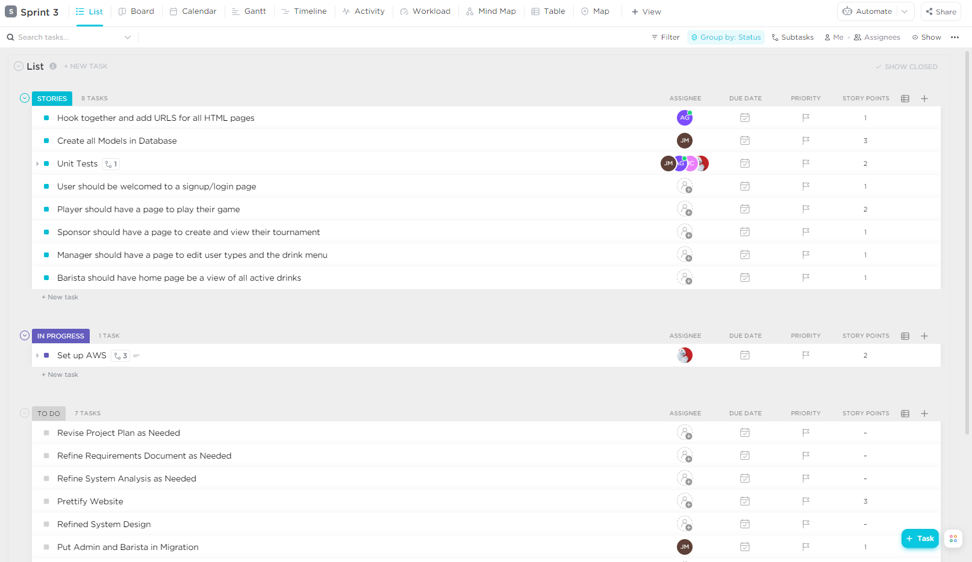

Burndown Chart of Story points

